**Assignment 3, Golang.**

**Frontend and Backend Integration: Building a To-Do List App Using Golang and React**

Student name: Amira Ordiyeva 22B22B1562

Course title: Golang application development

Date: 03/11/2024

**Table of Contents**

1. Introduction
2. Connecting with Frontend, Part 1
   * Overview
   * Exercises
     + Exercise 1: Setting Up a Simple Golang API
     + Exercise 2: Consuming API with React
   * Findings
3. Connecting with Frontend, Part 2
   * Overview
   * Exercises
     + Exercise 3: Handling API Responses in React
     + Exercise 4: State Management
   * Findings
4. Authentication and Authorization
   * Overview
   * Exercises
     + Exercise 5: Implementing JWT Authentication in Golang
     + Exercise 6: Integrating JWT in React
     + Exercise 7: Role-Based Access Control (RBAC)
   * Findings
5. Conclusion
6. References

**Introduction**

In this project, I am creating a program that connects the frontend and backend using an API built in Golang and a React application. The importance of integrating the frontend and backend is to enable interaction between the client and server parts, which allows you to create dynamic and secure web applications. I have created an application that is a to-do list with the ability to log in for users. After logging in, they can create, edit, view, and delete the tasks they have created.

**Connecting with Frontend, Part 1**

**Overview**

This report covers the key points of frontend and backend integration in web applications. The main focus is on building a task management application - a to-do list using React on the client side and Go on the server side. The integration of these technologies not only demonstrates the power of APIs, but also highlights the need for a robust authentication system.Objective: Create a basic RESTful API using Golang.

I create a directory for the project:

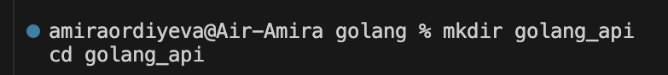

I Initialize the Go module: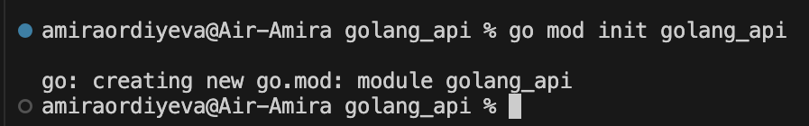

I installed Gin using the following command:

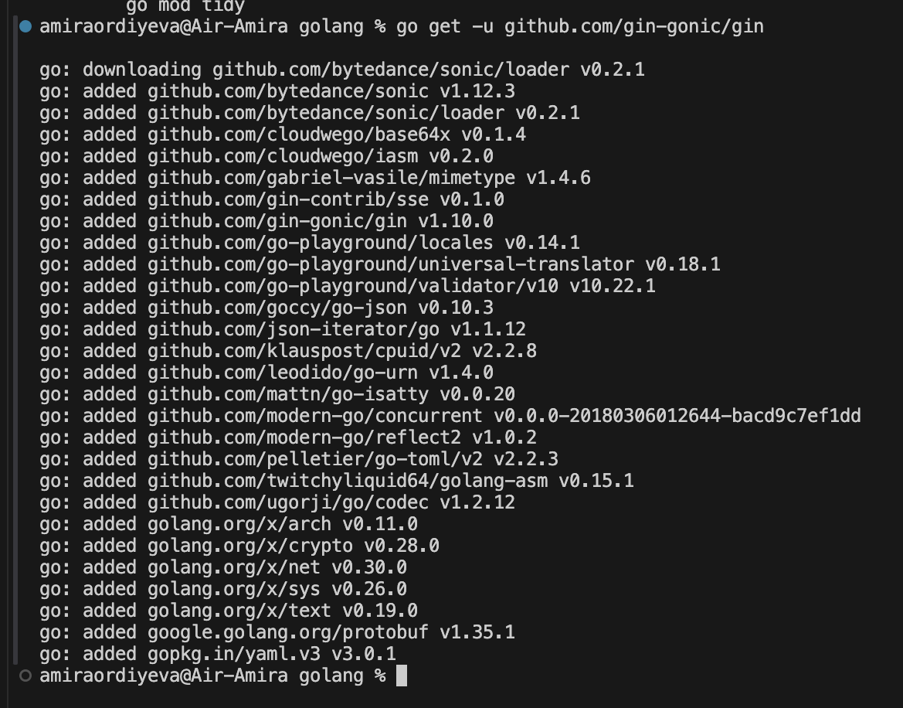

Now we can start implementing the basic API in the main.go file:

In the first line of code, I import the necessary packages.

net/http is responsible for handling HTTP requests,

strings is used to work with strings,

and time is used to work with time. I also import packages for working with JWT and the Gin framework for web development.

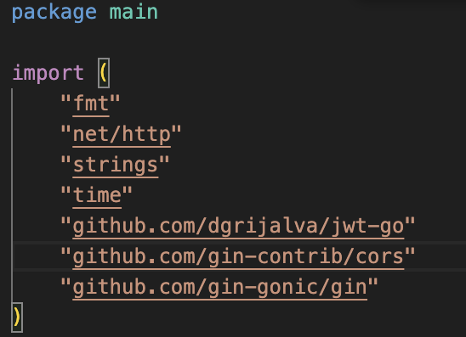

define a secret key that is used to sign JWT tokens. This key should be protected and should not be accessible to users.

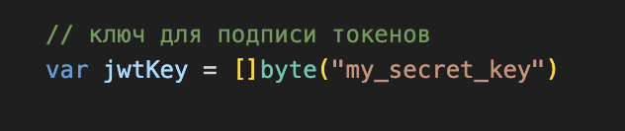

We define several structures:

The first is User which stores information about the user, including name, password and role.

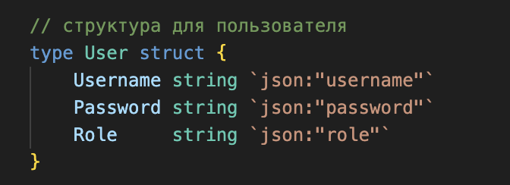

The Task structure represents a task with a unique ID, a name, and the name of the user who owns it.

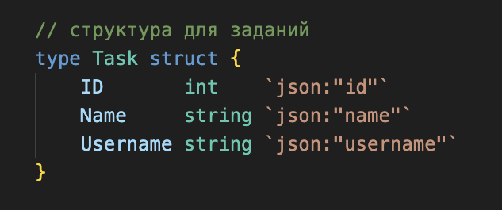

The Claims structure contains information about the user that will be encoded in the JWT.

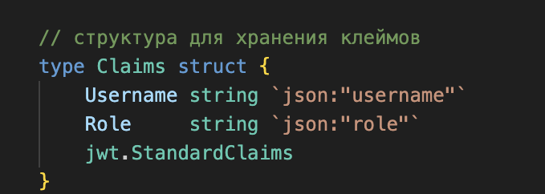

Task and user lists create lists of tasks and users. Here I pre-add two users administrator and normal user

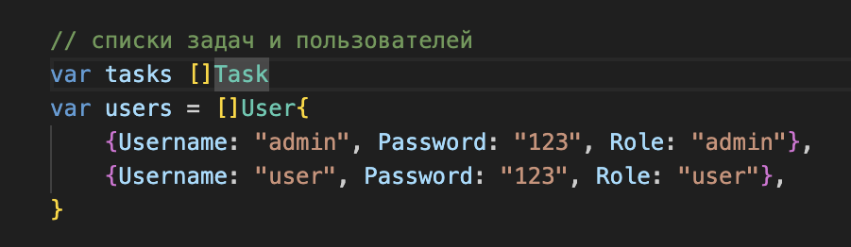

Here is the main function now I will describe in detail what is happening here

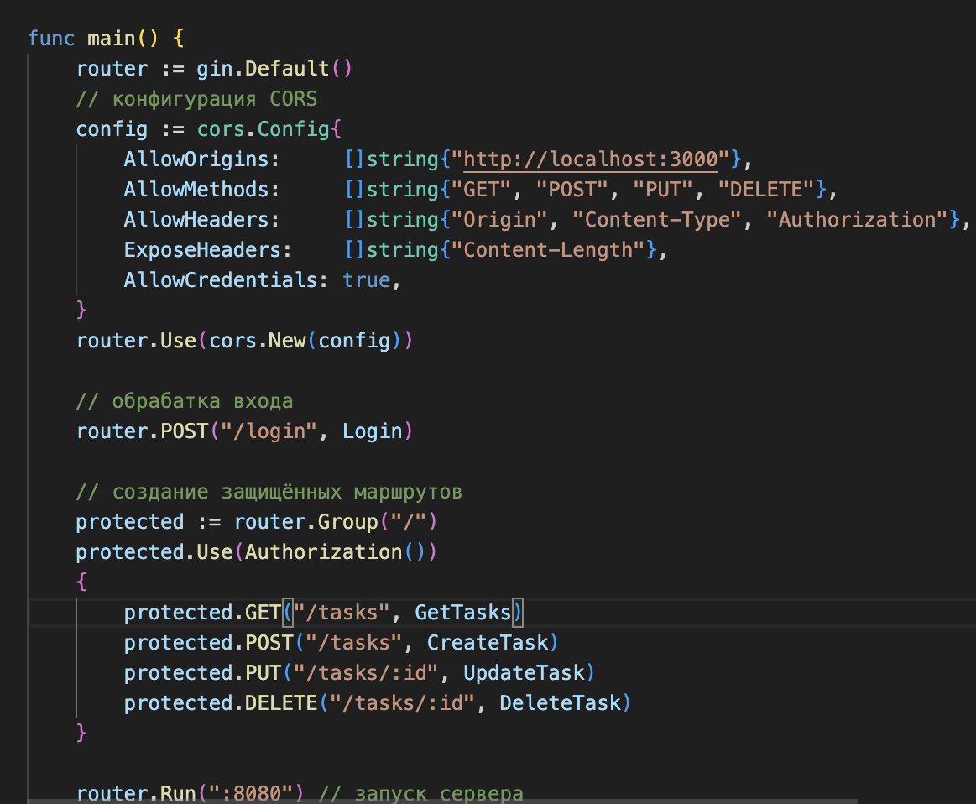

creating a new instance of the Gin router.

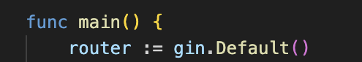

I'm setting up CORS to allow requests from a frontend running on http://localhost:3000.

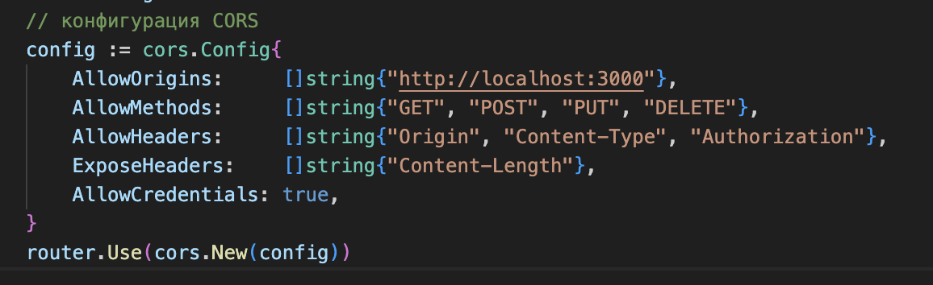

I declare a handler for the /login route, which is responsible for user authentication.

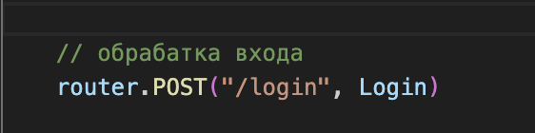

I create secure routes for working with tasks (GET, POST, PUT, DELETE) that require a valid JWT token.

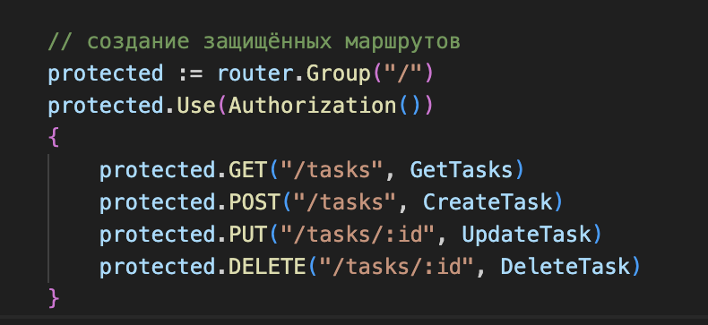

starts the server on port 8080

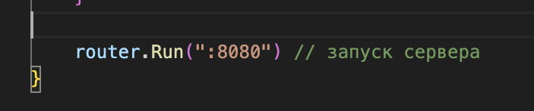

Returns a list of tasks for the current user. c *gin.Context is a context containing information about the request and response.

Using c.MustGet("username") I get the username from the context that was set in the authorization function. If the username is not found, a panic exception will be raised.

The tasks are filtered as follows: an empty slice userTasks is created to store the tasks of the current user. Then, all tasks are looped through and only those belonging to the current user are added.

To send the response, we use the c.JSON method to return the filtered tasks in JSON format with an HTTP status of 200.

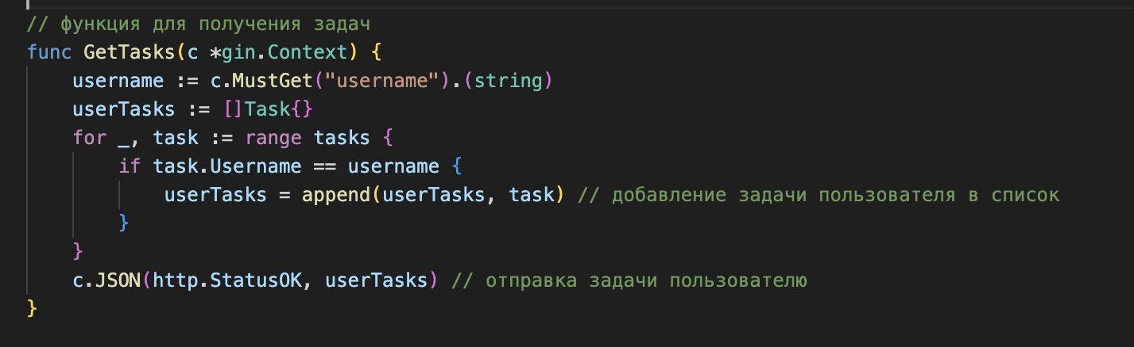

Creates a new task. Input parameters: c *gin.Context. Declare a variable task of the Task type. Using c.BindJSON(&task) fill this variable with data from the request (in JSON format). If the data is incorrect, send an error. Each new task is assigned a unique ID from the currentID variable, which is then incremented. Next, the username obtained from the context is saved in the task. And the created task is added to the tasks slice. Return the created task back to the client with HTTP status 200.

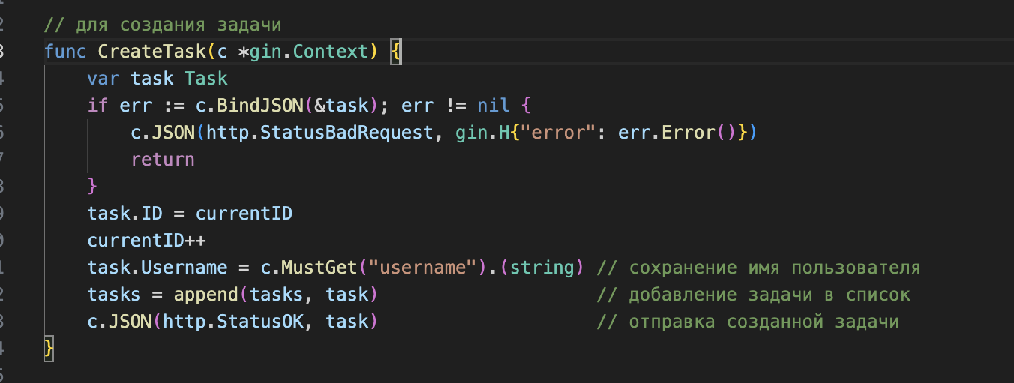

The logic is similar to the previous functions, only here an existing task is updated by ID. In the loop, I search for a task with the corresponding ID. If such a task is found: Checking access rights: Compare the user name that the task belongs to with the current user. If they do not match, send a 403 error. Update the task name to the new value from updatedTask.

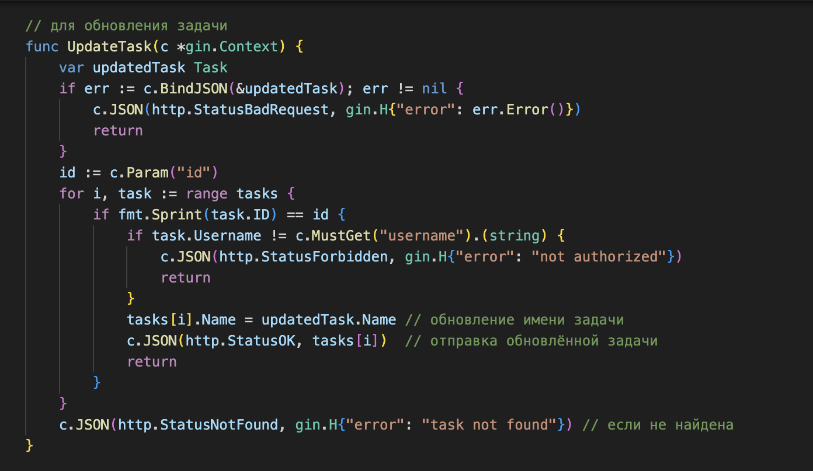

Deletes a task by ID. I use append to remove a task from a tasks slice. The removal is done by joining two parts: before the found index and after it.

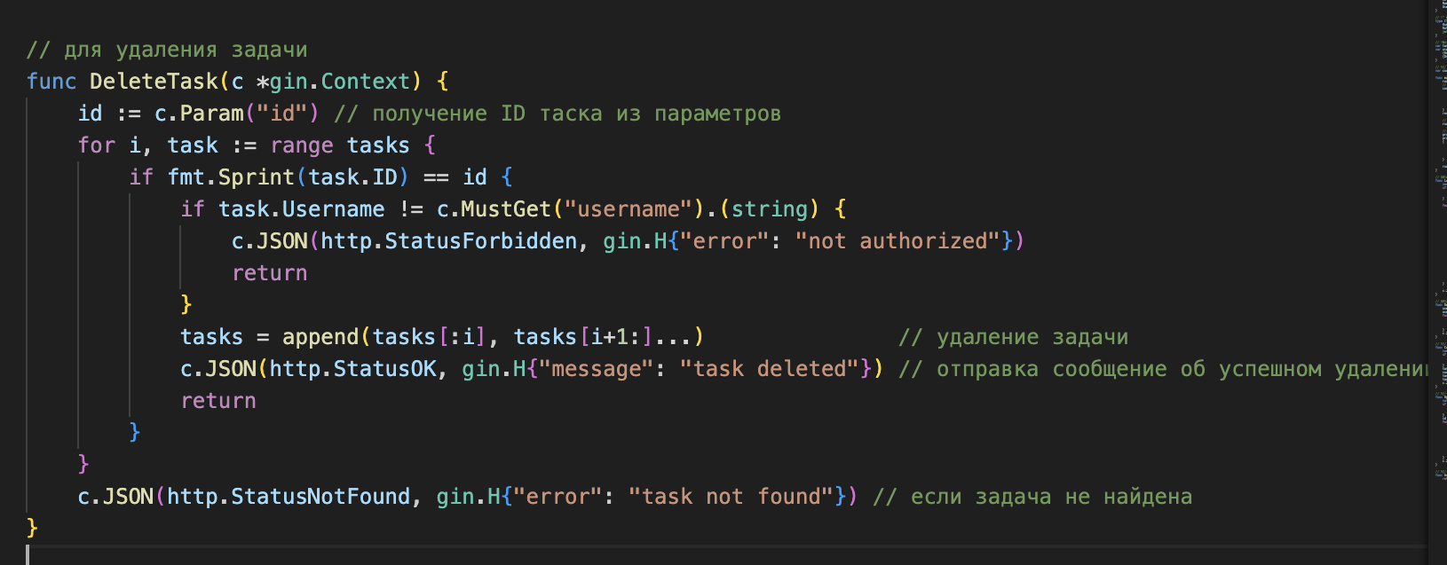

To compile the code I use the command in the terminal go run main.go.

As you can see, the server starts successfully and will be available at http://localhost:8080.

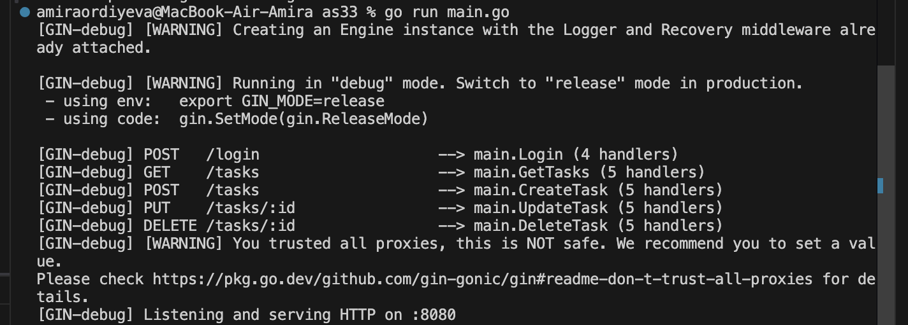

**Findings**

There were some issues with CORS (Cross-Origin Resource Sharing) during the API setup,

which required changes to the server configuration. It was also difficult to properly set up states in React to manage the data being received.

**Connecting with Frontend, Part 2**

**Overview**

In the second part of the project, I delved into advanced topics such as state management and handling complex API responses.

Objective**:** Build a simple React application that connects to the Golang API.

I Create a new React project:



I'm installing axios



I create a new file itemlist.js that will receive data from the Golang API and display it. Now I will explain this code in parts

First, I import the necessary modules and components, including React, axios, and the authentication context.

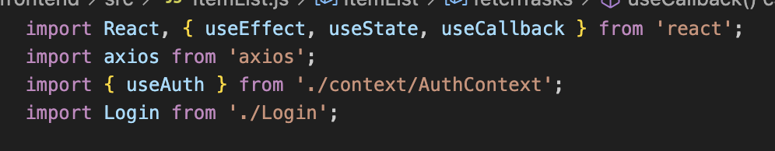

Itemlist.js is responsible for displaying the task list, as well as creating, editing and deleting tasks.

tasks: array of tasks retrieved from the API.

taskName: string containing the name of the new or edited task.

loading: boolean indicating that data is loading.

editingTask: task currently being edited.

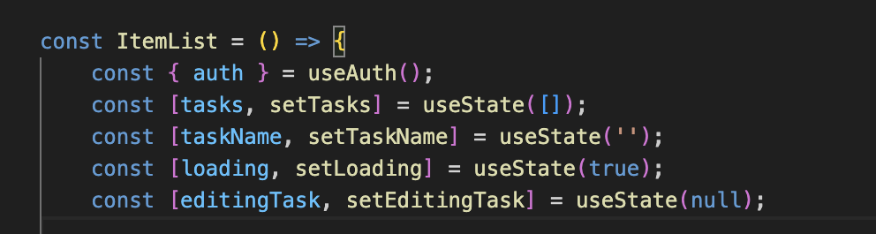

The fetchTasks function is used to get tasks from the API. It makes a GET request to http://localhost:8080/tasks , passing the authorization token in the headers. If everything works correctly, the received tasks are saved in the tasks state.

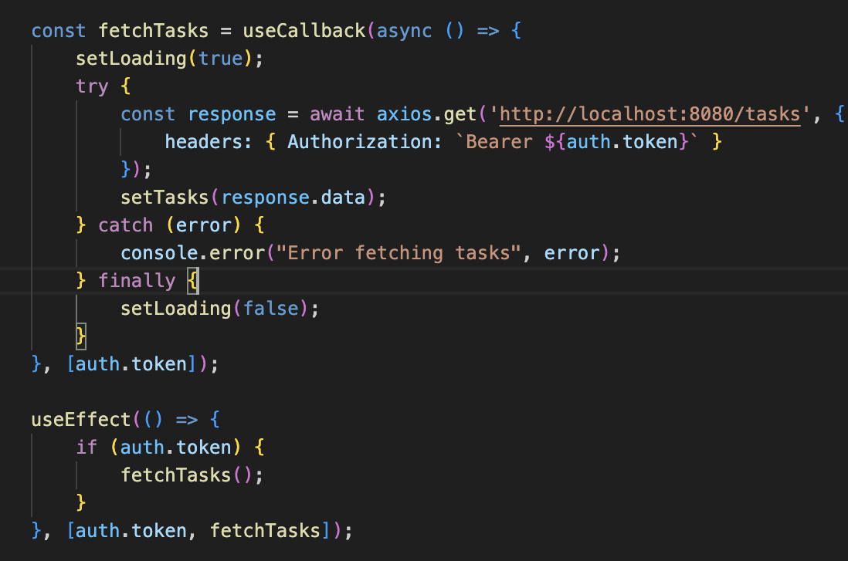

Used to call fetchTasks when the authorization token changes.



This function sends a POST request to create a new task. If the task is successfully created, it is added to the tasks state.

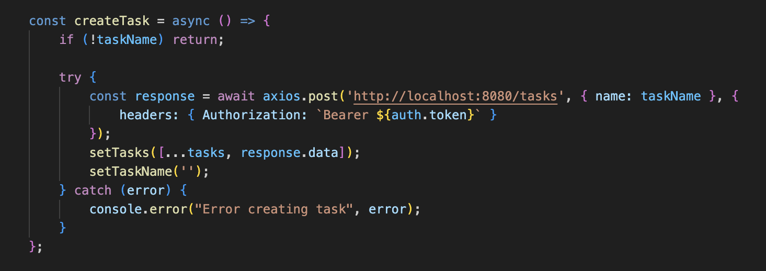

When this function is called, a DELETE request is sent to delete a task by its ID. After deletion, fetchTasks is called to update the list of tasks.

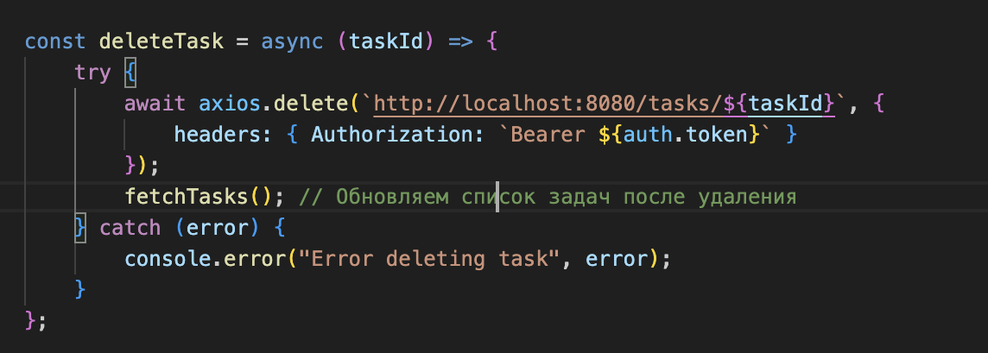

This function fills the input field with the value of the task being edited and sets it to the editingTask state.

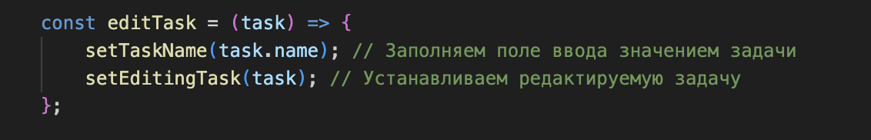

A PUT request is sent to update the task information. After a successful update, the input field is cleared and the state of the edited task is reset.

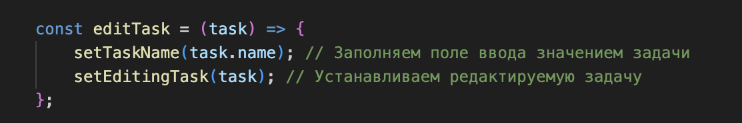

A PUT request is sent to update the task information. After a successful update, the input field is cleared and the state of the edited task is reset.

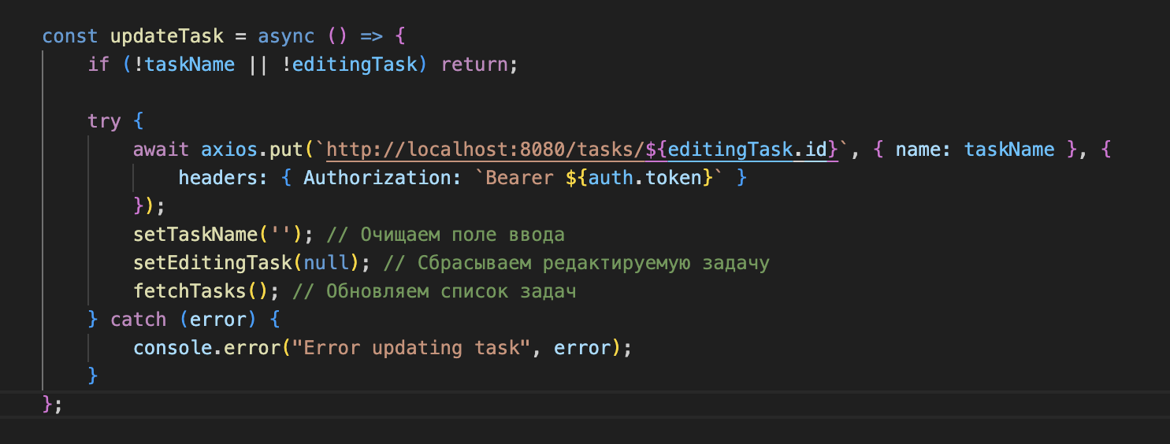

If there is no authentication token, the Login component is displayed. Otherwise, the task list and a form for creating or editing tasks are displayed.

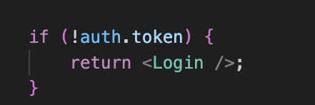

Now I need to update app.js the existing file so that it uses my new component itemlist.js

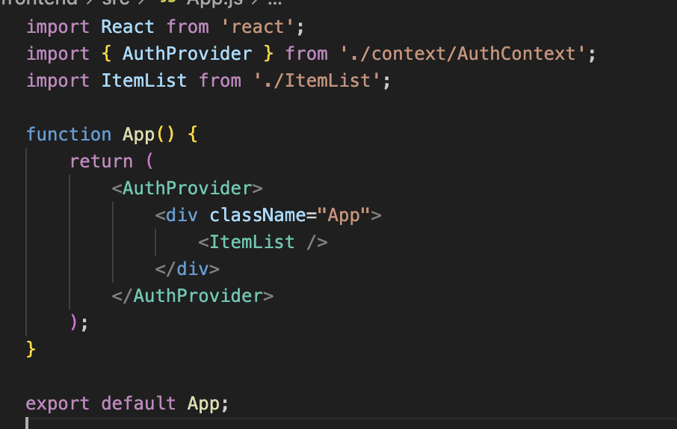

For compilation I am using npm start command in terminal

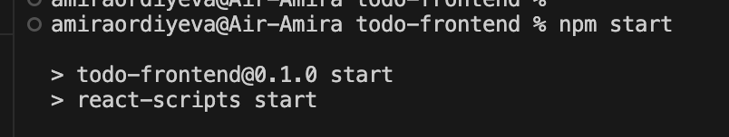

Now my application will run at http://localhost:3000 and I will be able to see the list of tasks loaded from your Golang API.

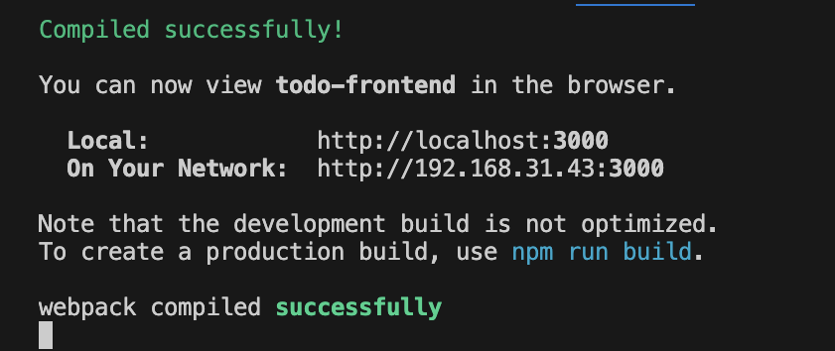

**Findings**

While working on improving the handling of API responses, I noticed that using Redux really helps manage the state of the application more easily. It makes the interface more responsive for users. This gives users a smoother and more enjoyable experience with the application.

**Authentication and Authorization**

**Overview:**

Authentication and authorization are key aspects of application security. Authentication verifies that a user is who they claim to be, while authorization determines their access rights. These mechanisms are necessary to protect user data and prevent unauthorized access, making them critical for any application.

Let's start by looking at the file first main.go

This is the secret key used to sign the JWT. It should be kept secure and should not be accessible to unauthorized users.

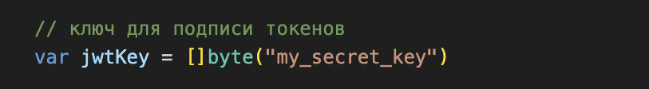

A structure that describes the tokens in a JWT. It contains the username, role, and standard tokens, such as an expiration time.

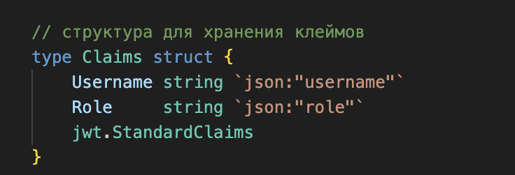

Login function. Let’s talk about it more detailed/

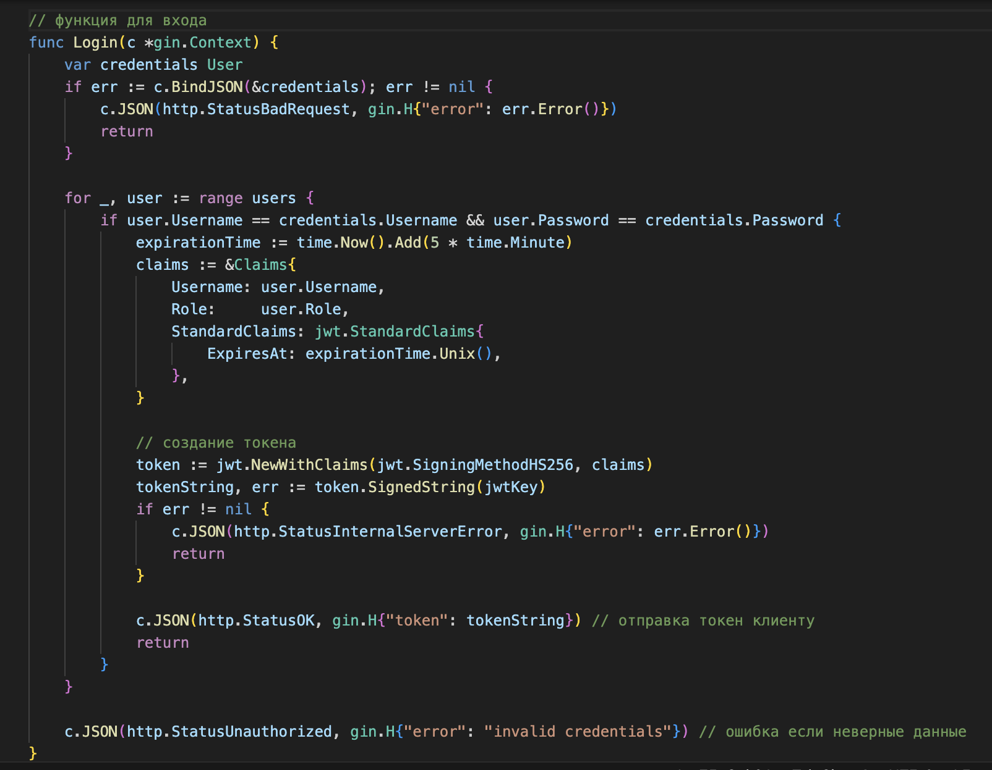

At this point, I get the credentials. I create a variable called credentials of type User that will store the username and password obtained from the JSON request. The BindJSON method attempts to bind the data from the request body to the User structure. If this fails, we send a response with the 400 code and an error message.

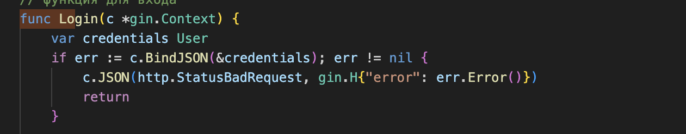

I check the users. I go through all the users in the users section and check whether the username and password match those entered by the user.



I set the token expiration time to 5 minutes from the moment it is created. I create a claims structure that includes the username, their role, and the token expiration time.

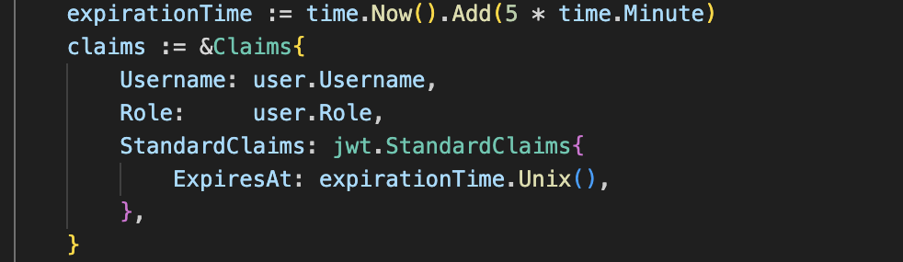

I use the JWT library to create a new token with the specified claims. The SignedString method signs the token using the jwtKey. If an error occurs, we send a response with the code 500

Sending the token: If the token is successfully created, we send it to the client with the code 200 .

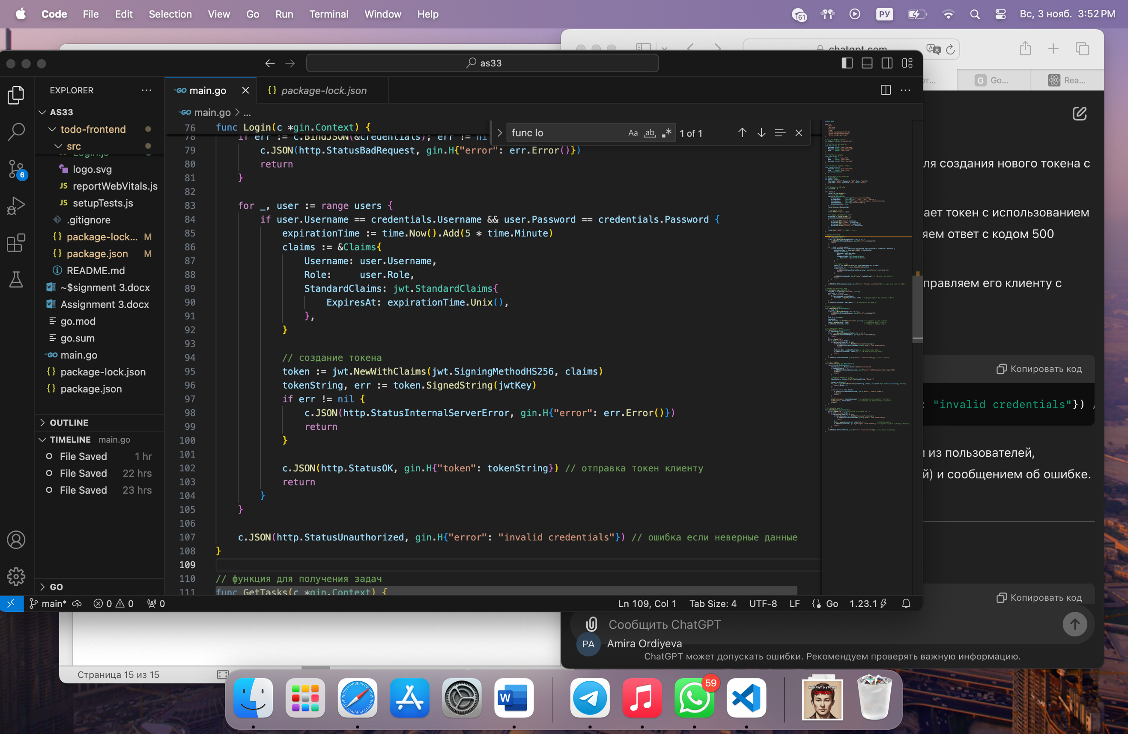

If the entered data does not match any of the users, we send a response with code 401 and an error message.

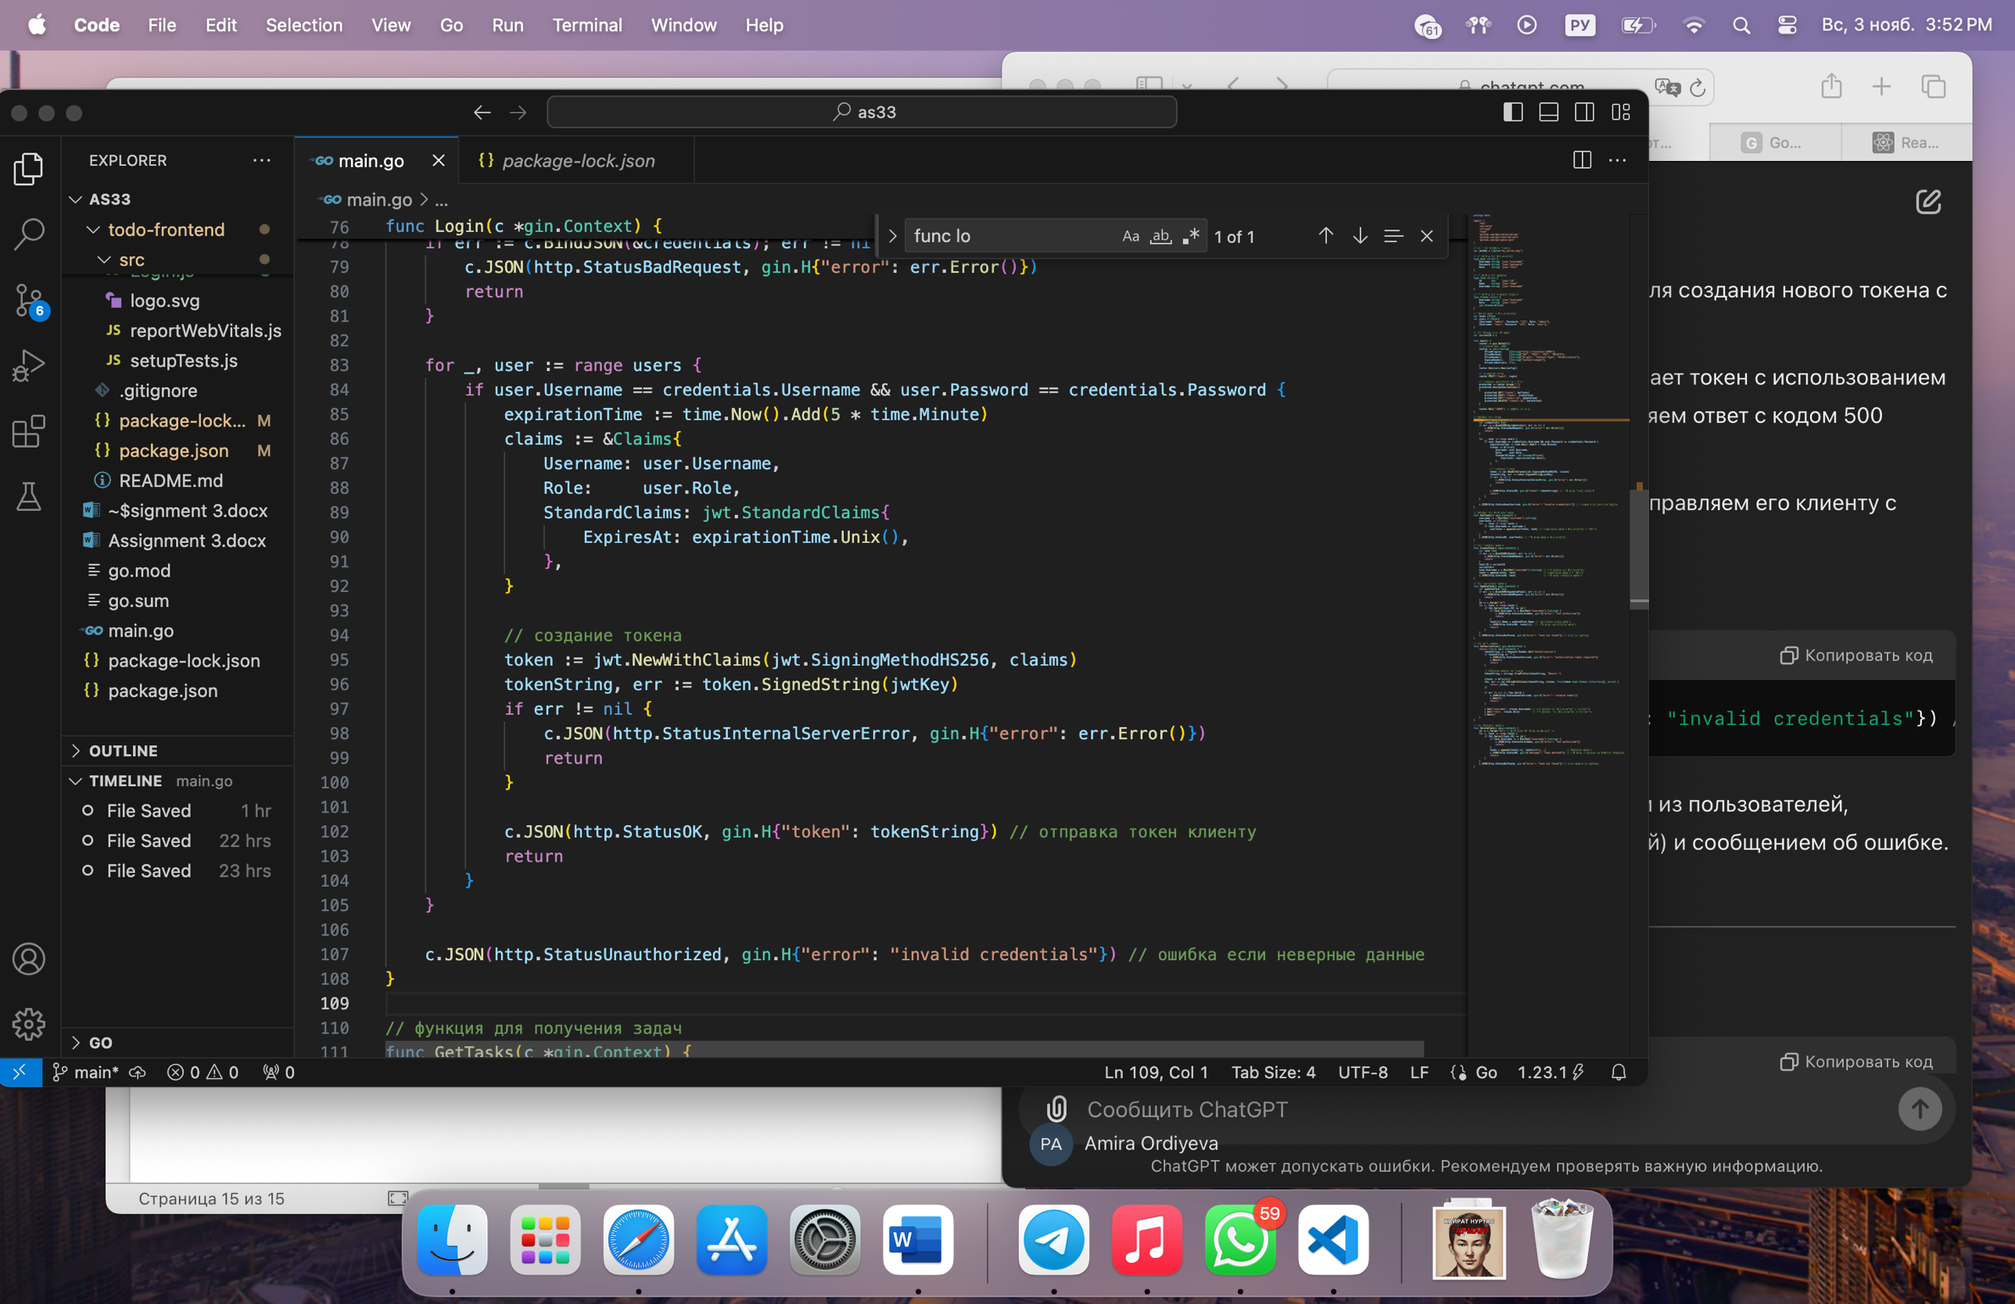

Authorization function

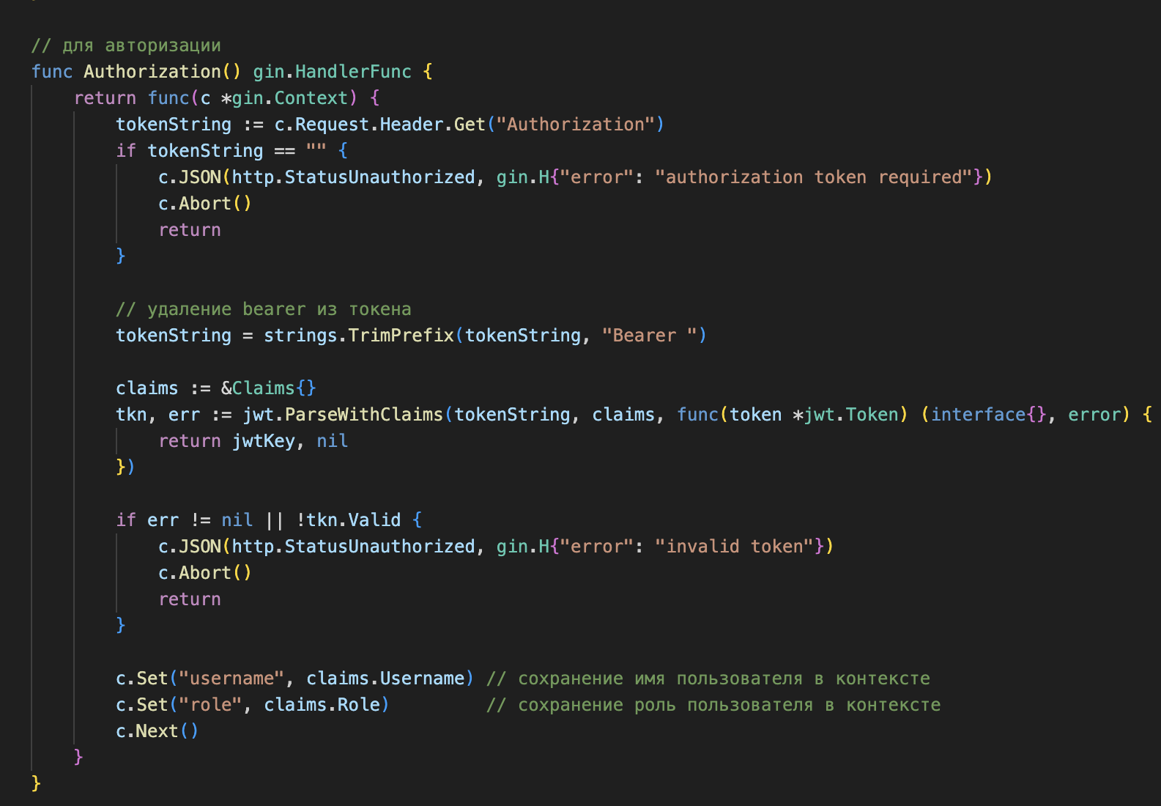

I extract the token from the Authorization header of the request. If the token is missing, I send a response with the code 401 and an error message.

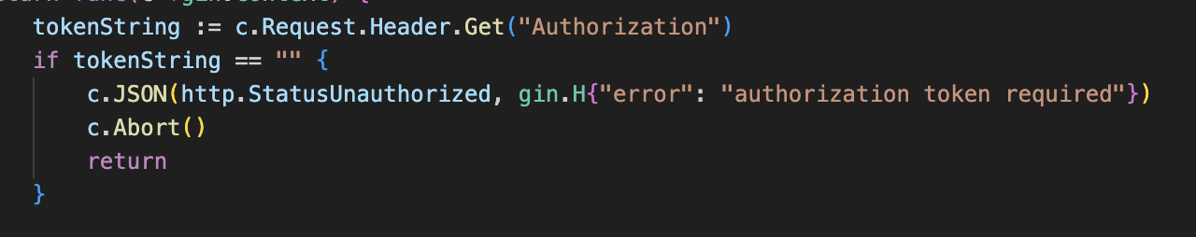

I remove the Bearer prefix from the token so that only the token string remains.

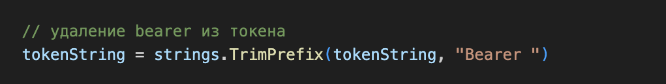

I parse the token using the ParseWithClaims function, which extracts the claims and verifies the token signature using the jwtKey. If an error occurs or the token is invalid, I send a response with the code 401

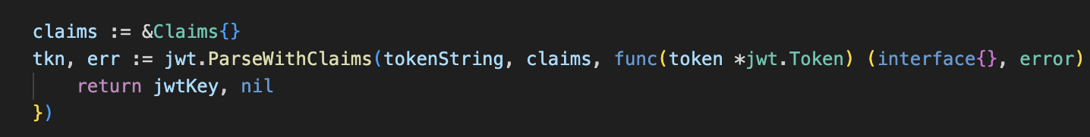

I save the username and role in the Gin context so that they are available to subsequent handlers. Then I call c.Next() to continue executing the next handlers in the chain.

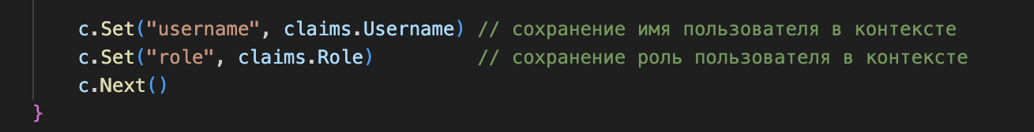

Now let's talk about login.js. It implements a component for user login to the application, interacting with the server part, which is responsible for authentication.

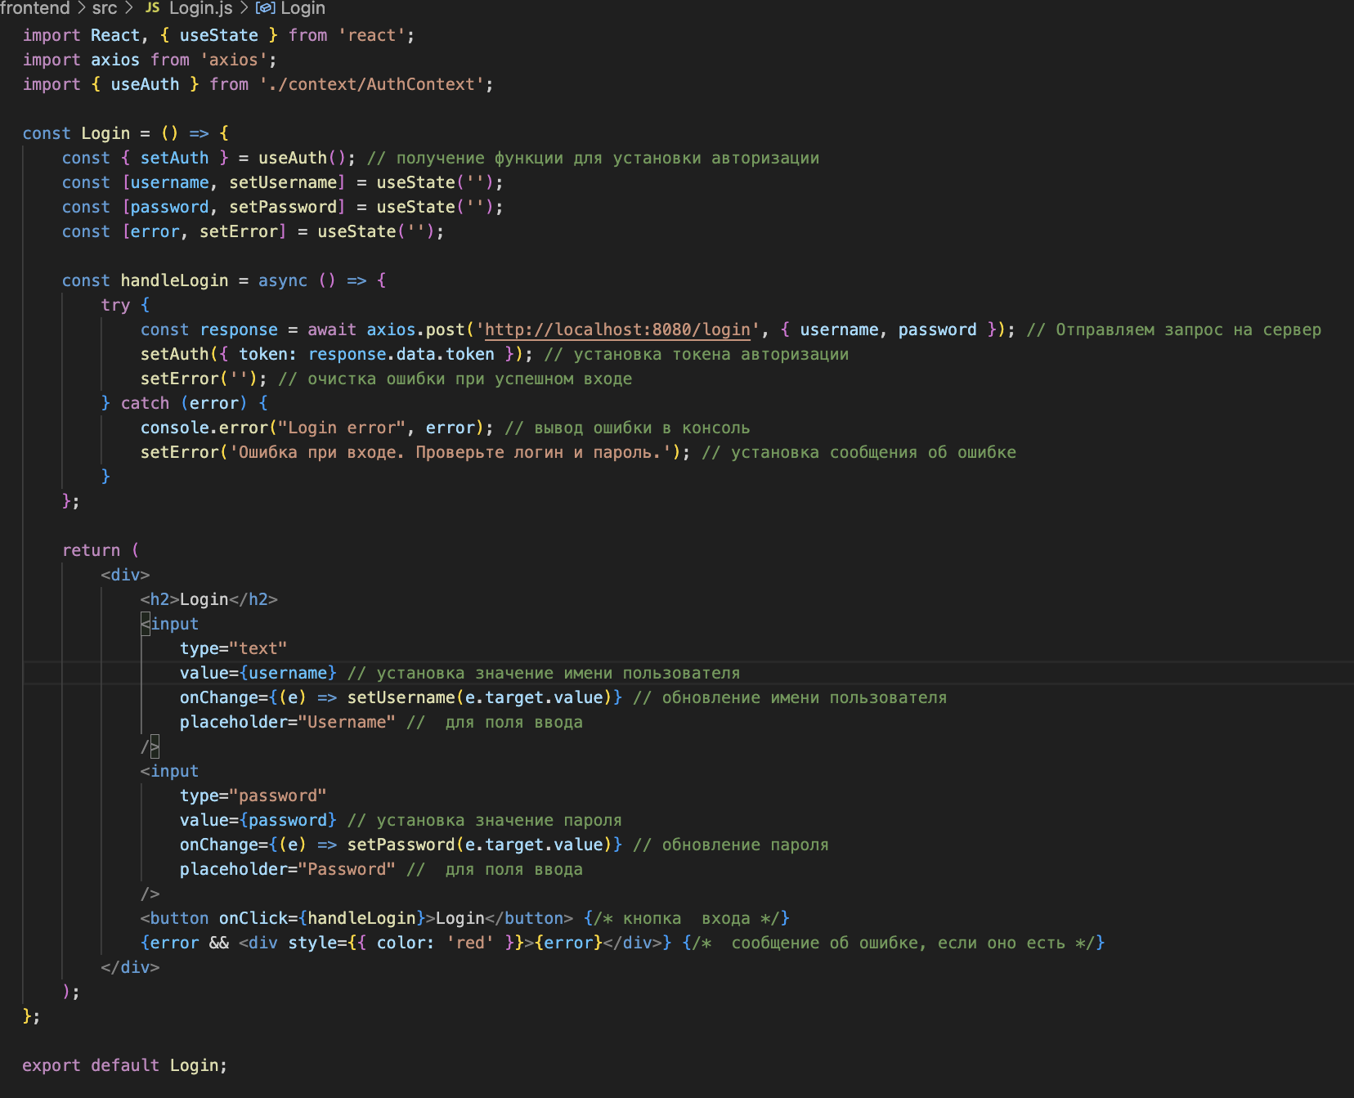

Login component definition. setAuth: Function to set the authorization state, which allows you to save the token. useState: Create states to store the username, password, and error messages.



I do login processing.

handleLogin: Asynchronous function for handling user login. Then I send a POST request to the server with the username and password. If the request is successful, I save the received token using setAuth. If login fails, I display an error message.



in the end I get this application on react with the ability to authorize

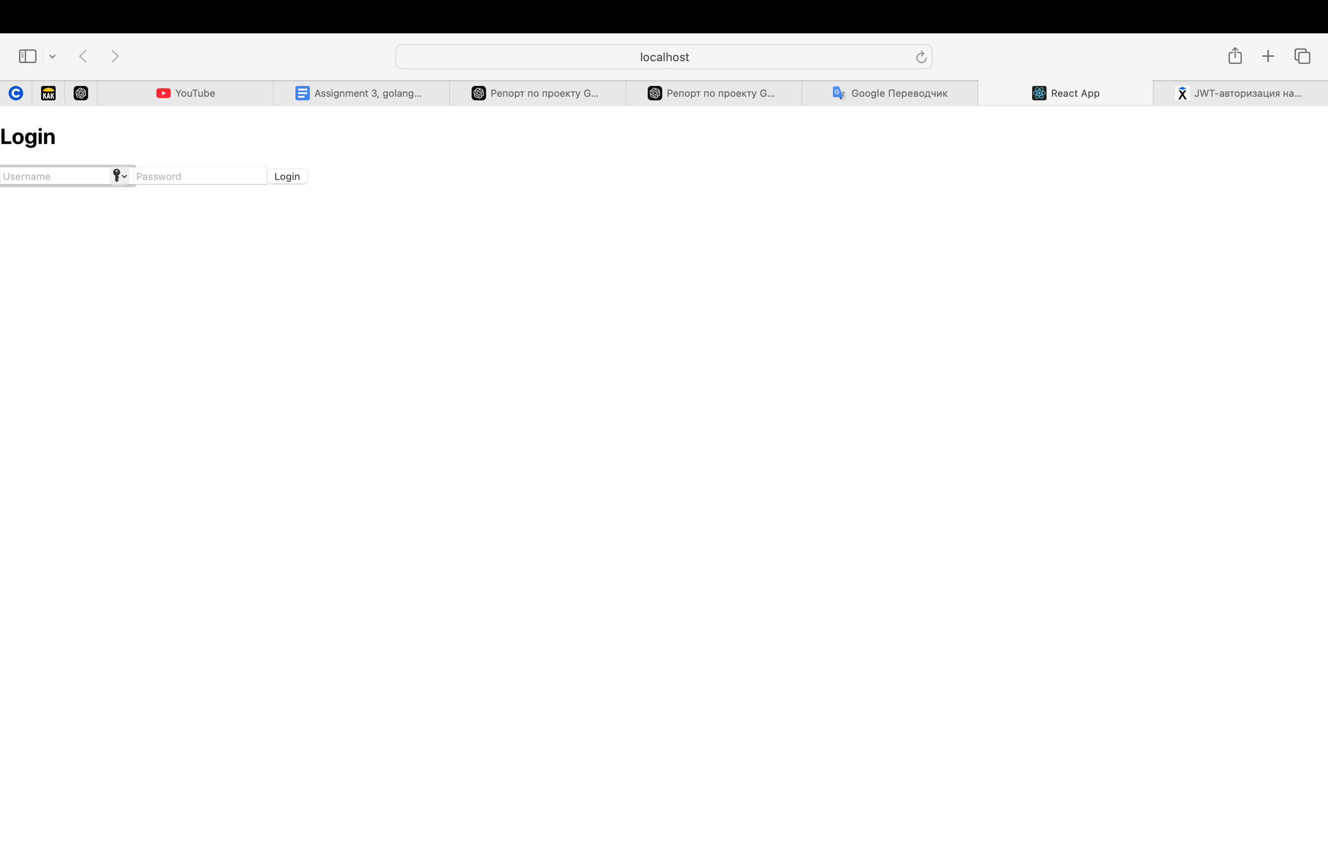

then we enter and go through authorization

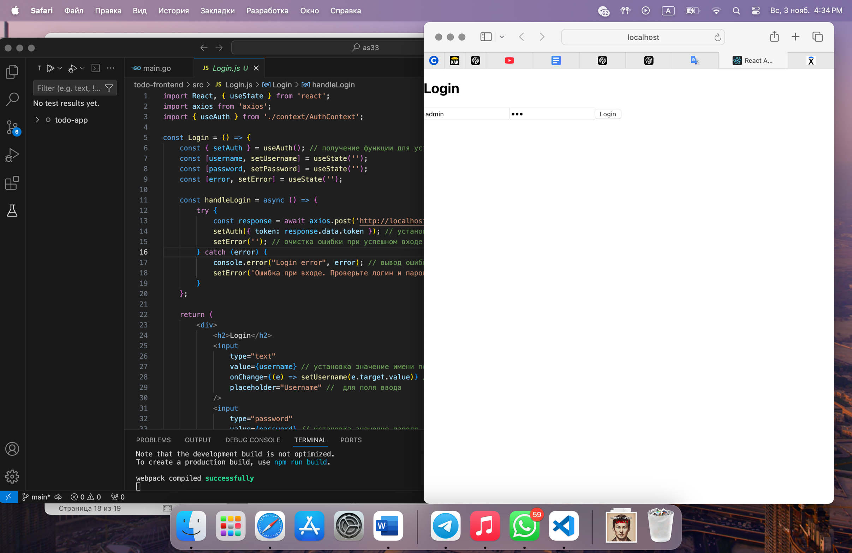

after successful authorization we see the opportunity to create our own task

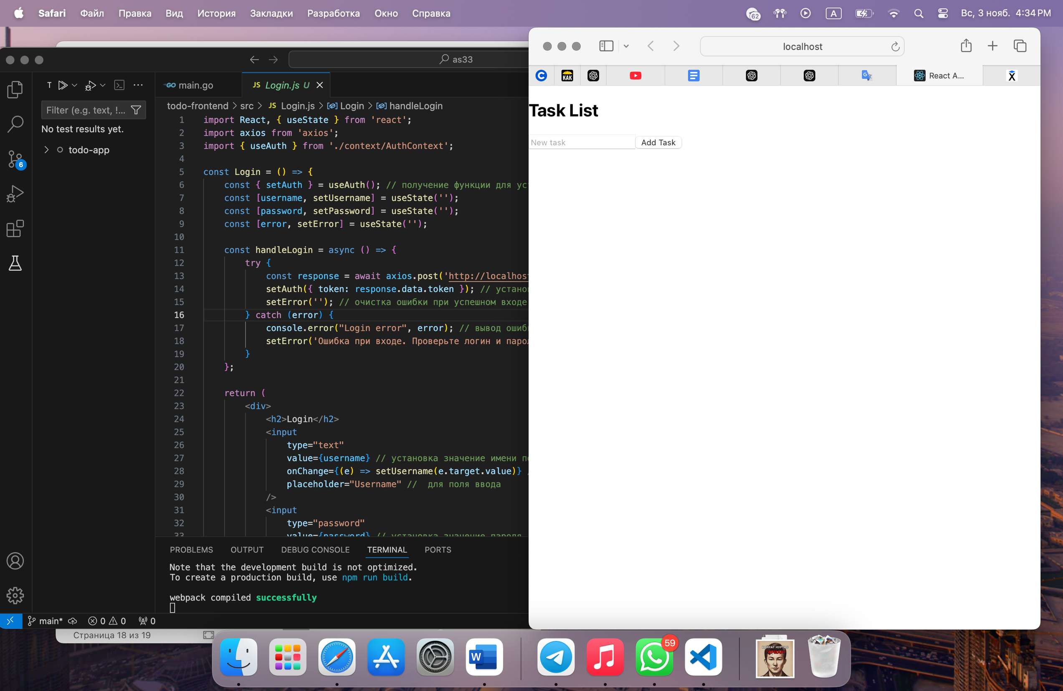

After creating a task, you can edit it or delete it

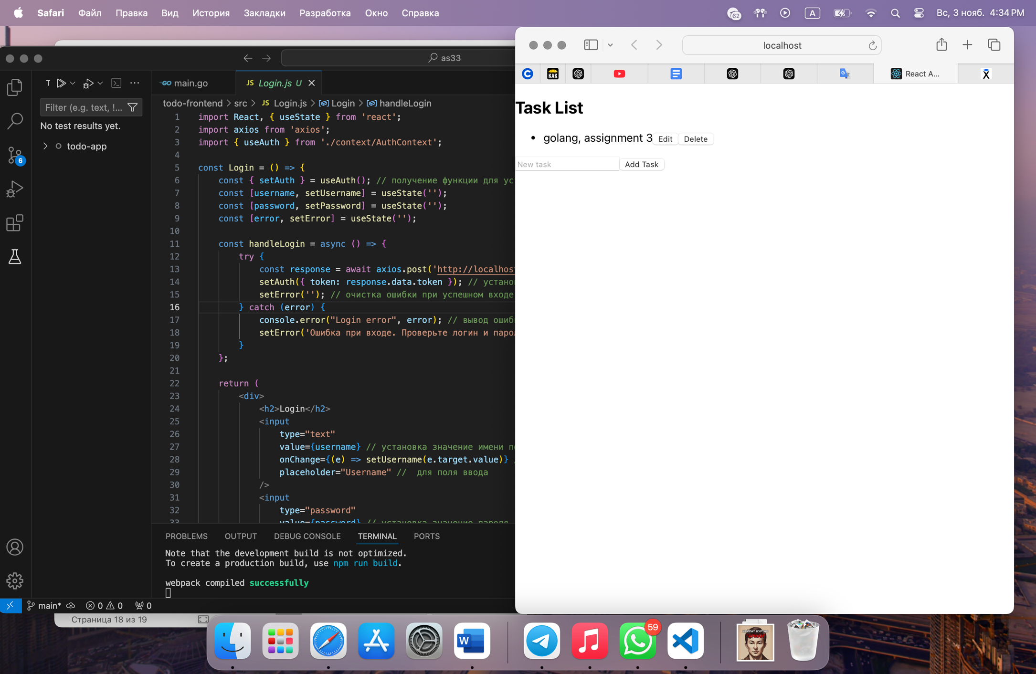

this is what changing a task looks like

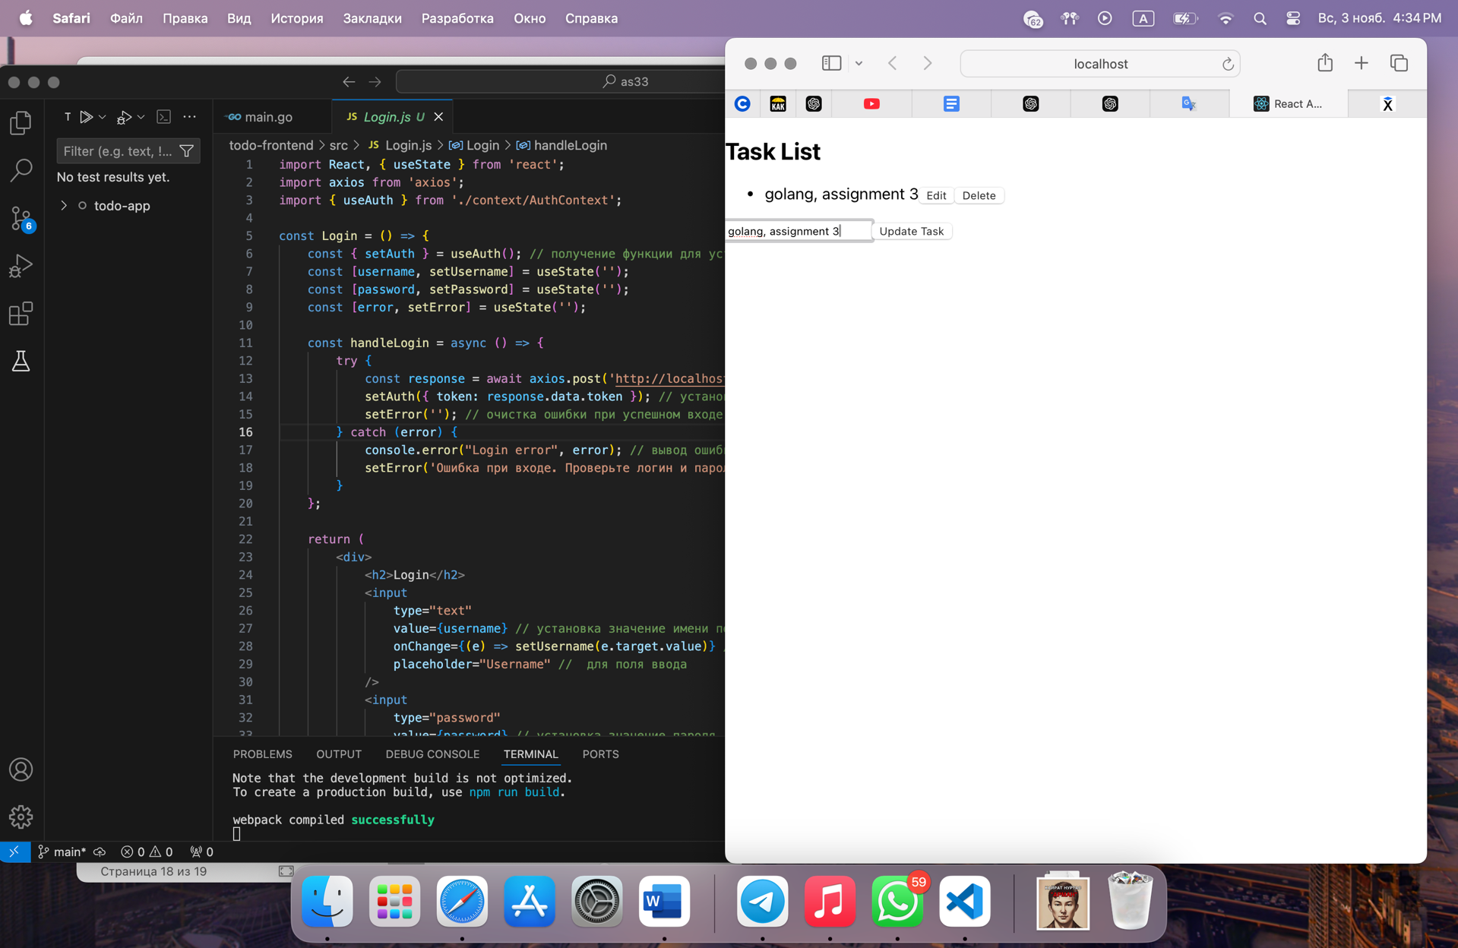

We can also perform a check in Postman to test the API and ensure that authentication and various scenarios of interaction with the application work correctly.

at this stage I get a token so that I can work with it later

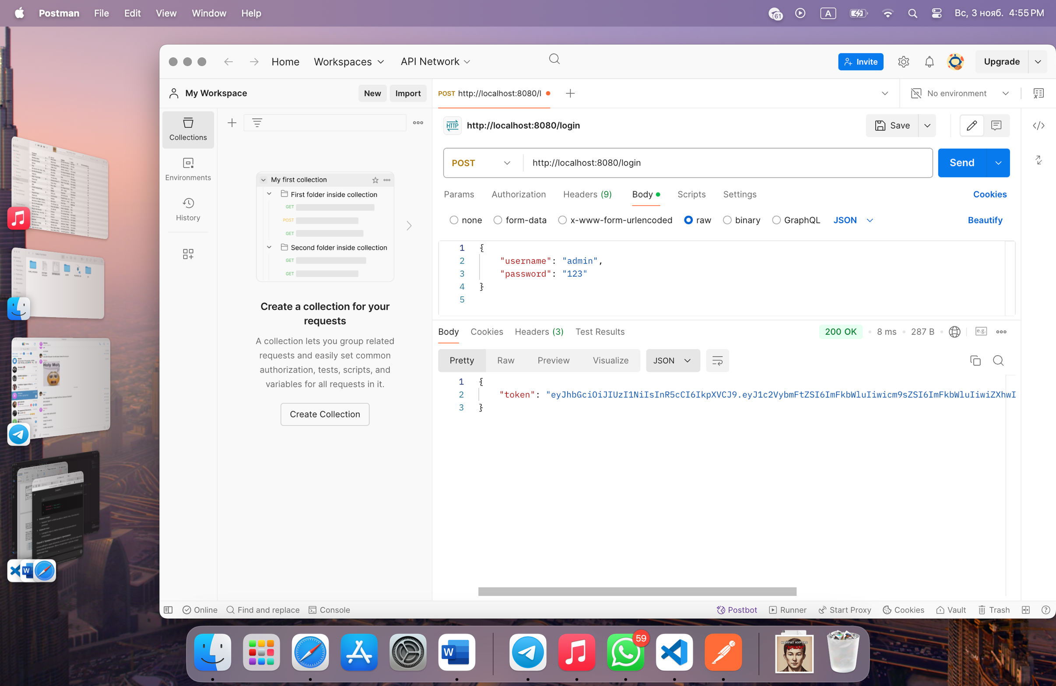

using the token and the get request I got the tasks that I have

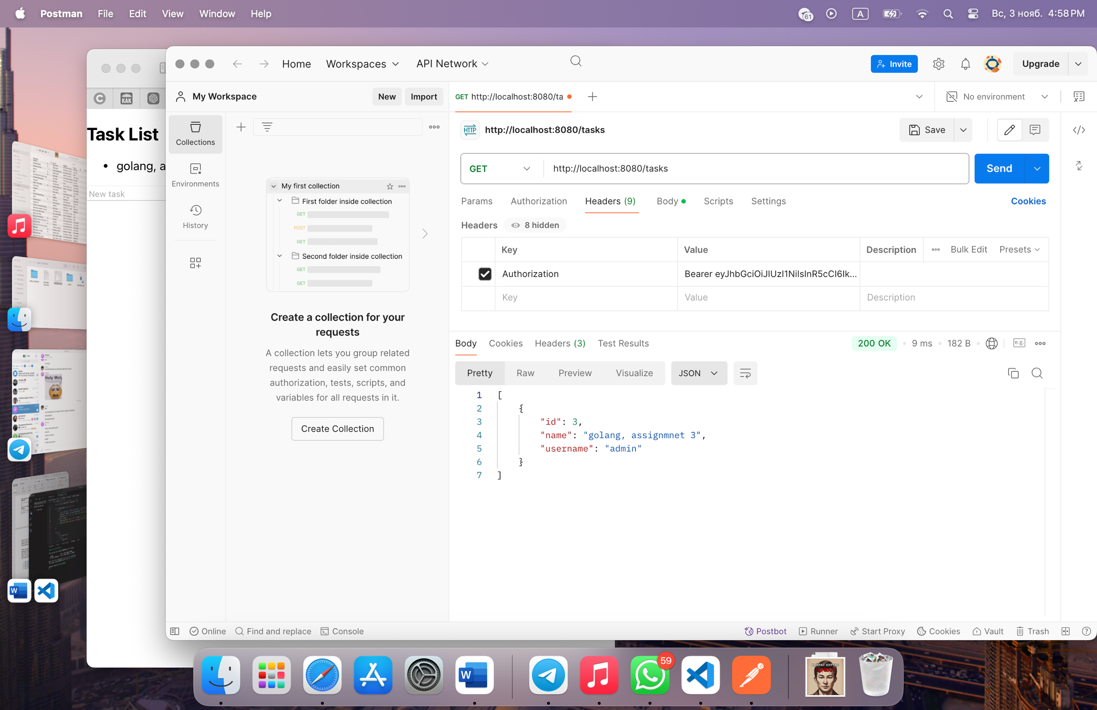

**Findings:**

Implementing JWT for authentication was useful because it simplified the user verification process and provided security. However, there were challenges such as token expiration and unclear error messages, which caused user frustration. This experience taught me the importance of user-friendliness and robustness in error handling.

**Conclusion**

While working on this project, I learned a lot about building web applications. I learned how important it is to properly configure the connection between the frontend and the backend so that data can flow between them efficiently. I also learned how important authentication and authorization are to protect user information. Understanding JWT and access control helped me build a more secure application. In the future, I will be able to apply this knowledge to develop more complex projects where security and user experience are key.

**References**

1. <https://jwt.io>
2. <https://developer.mozilla.org/en-US/docs/Web/HTTP/CORS>
3. <https://kz.hexlet.io/courses/go-web-development/lessons/auth/theory_unit>
4. <https://go.dev/doc/>
5. <https://github.com/dgrijalva/jwt-go>